**Ideation Phase**

**Problem Statements**

|  |  |
| --- | --- |
| Date | 9 September 2022 |
| Team ID | PNT2022TMID17179 |
| Project Name | Gas leakage monitoring and alerting system for industries |
| Maximum Marks | 2 Marks |

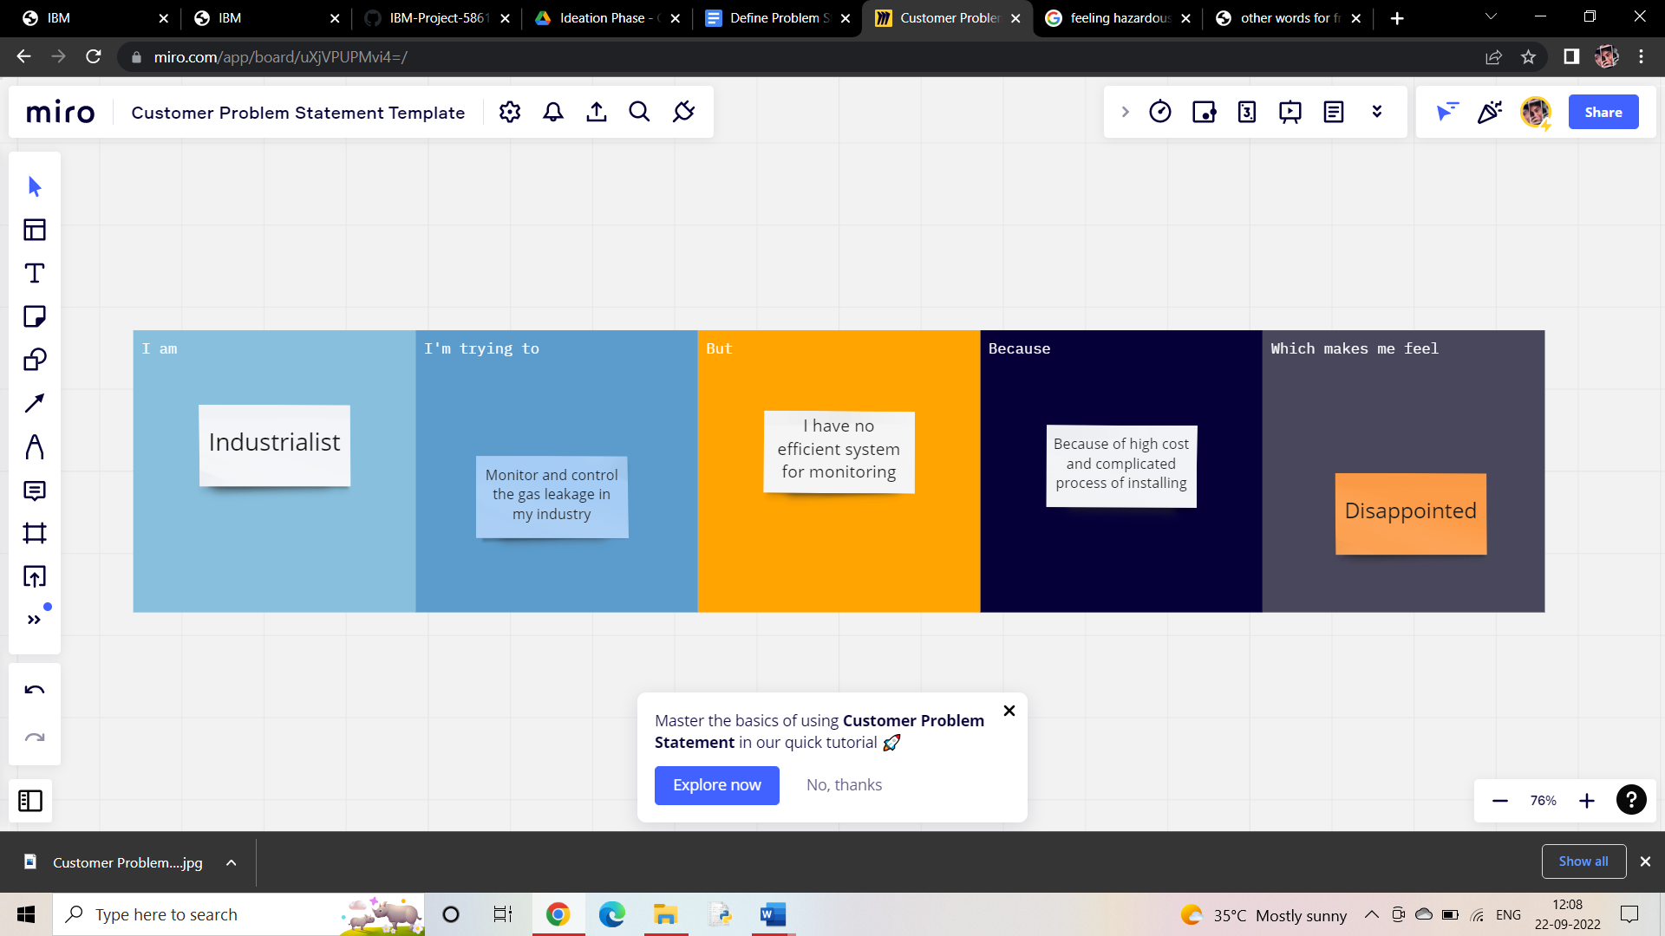

|  |  |  |  |  |  |
| --- | --- | --- | --- | --- | --- |
| **Problem Statement (PS)** | **I am (Customer)** | **I am trying to** | **But** | **Because** | **Which makes me feel** |
| PS-1 | Industrialist | Monitor gas leakage in the industry | I don’t have any system for monitoring | The affordable of the system is high and the systems are sometimes making disasters | Unsafe |
| PS-2 | Industrialist | Control the gas leakage | Also, the installation process is too complicated | The number of sensors is unpredictable and the positioning of equipment is improper | Disastrous |